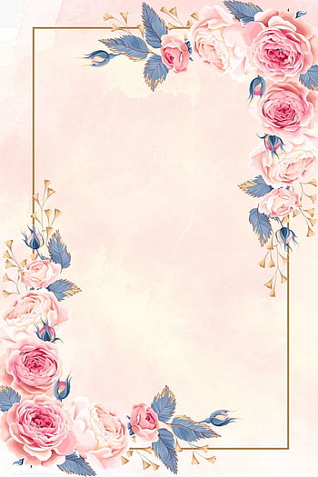

RICHARD

NATASHA

Together with our families, have

the pleasure to invite you to our wedding

invitation in west virginia on 22nd october 2023

**22nd**

**OCTOBER**

**WEDDING**

**INVITATION**